आईसीएमआर - राष्ट्रीय महिला स्वास्थ्य अनुसंधान संस्थान
ICMR-National Institute for Research on Women’s Health
जहांगीर मेरवानजी स्ट्रीट, परेल, मुंबई 400012
Jehangir Merwanji Street, Parel, Mumbai 400012

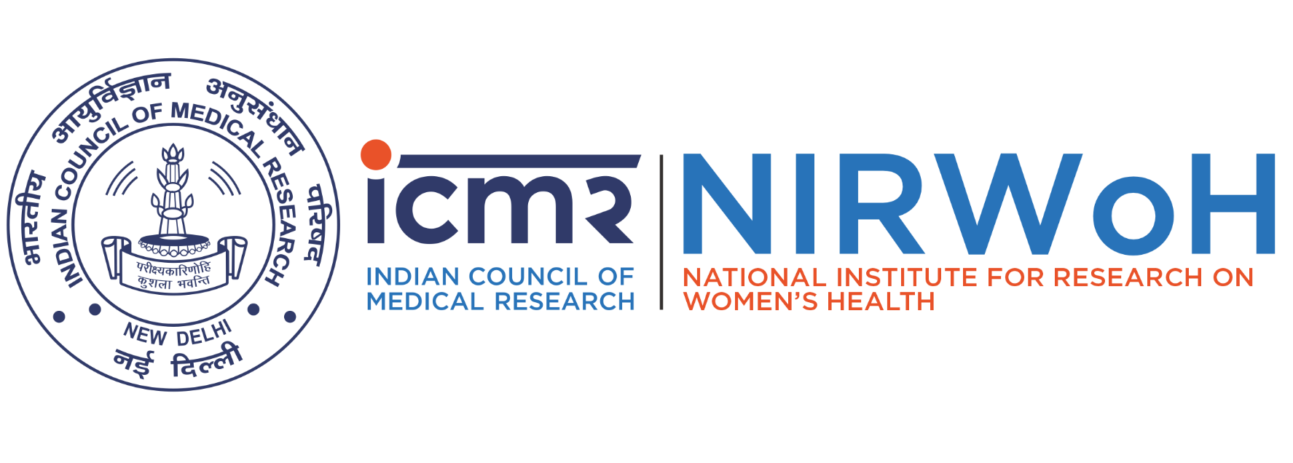
Walk-in-Interview through outsourcing agency, M/s. E-Solutions IT Services Pvt. Ltd., are scheduled on 08th May, 2026 from 11.00 AM to 12.00 PM for the following vacancy for the Project Study “Impact of Muktashukti Bhasma and Saubhagya Shunthi Churna in reversal of bone mineral density among lactating women consuming traditional diet foods in Maharashtra-A Randomized controlled preliminary clinical study” funded by Central Council for Research in Ayurvedic Sciences (CCRAS) to be filled on purely temporary basis. Please submit your application on the below mentioned link, which will be screened before physical interaction. Candidates meeting of Eligible Qualification should only Apply.

Name of the Post | No. of vacancy | Consolidated Salary | Essential Qualification | Job Requirements / Description | Age Limit | Duration / Tenure
Dietician | One | Rs 27,456/-  (Rs 25,506/-  + Rs. 1950/- Employer PF contribution) | Graduate in science/relevant subjects- nutrition/ applied nutrition from a recognized University with 5 years work experience from a recognized institution or Master’s degree in relevant subjects- applied nutrition/ dietetics | • Community clinical nutrition  • Experience of conducting Research project work  • knowledge of computer applications like MS word, Excel, power point | 30 Years | Six months  (Further extension based on performance – Project Tenure up to 31.08.2027)
Place of Posting: Bone Health Clinic, 18 A Old BDD Chawl, Room Nos 8,9,10,14 Ground Floor, Between Lok Seva School and Bhavani Mata Temple, Mahatma Jyotiba Phule Road, Naigaon, Dadar East, Mumbai 400012

Link for Application: http://nauk.in/SoM8uc

